PROMISE & PRACTICE · DEEP DIVE · SOURCE ANALYSIS
The Atlanta Campaign — A House Divided
The City That Swung an Election
Name: ______________________________ Period: _____ Date: ________________
WHAT I CAN DO TODAY I can read primary sources about The Atlanta Campaign — A House Divided, weigh who made each one and why, and use evidence to answer historical questions.
Directions. History is not inevitable. Trace how one victory, at one moment, changed what came next

THE SOURCES
THE IMAGE · 1864 — The ruins of Atlanta
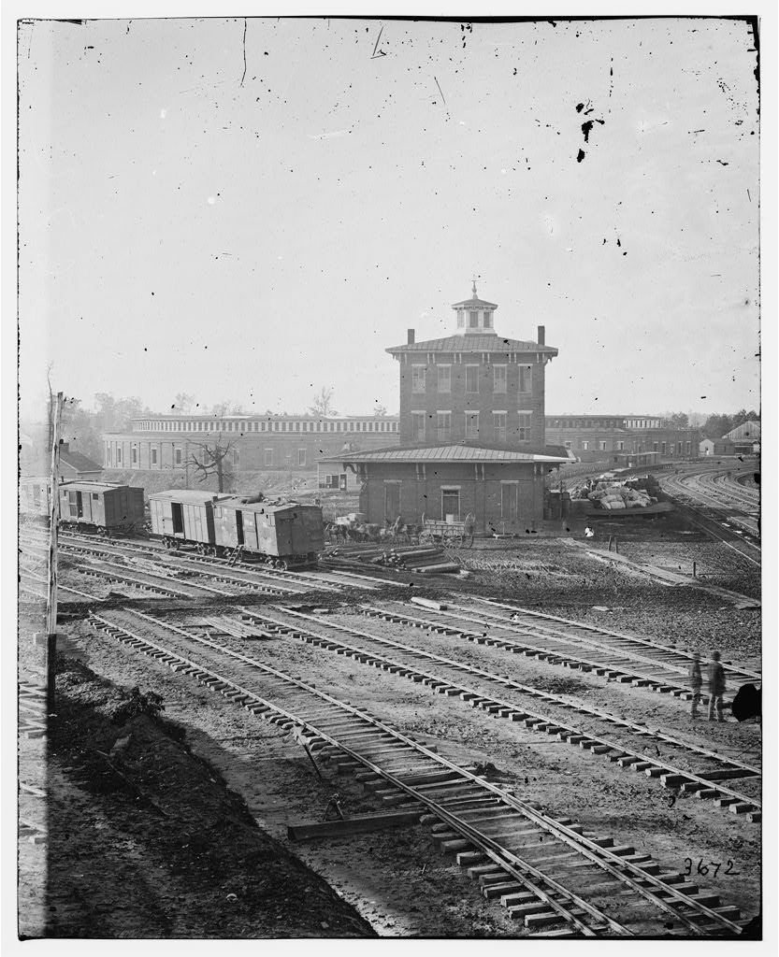
The destroyed railroad roundhouse, Atlanta — photograph by George N. Barnard, 1864, public domain (Library of Congress).
SOURCE · LINCOLN, BEFORE ATLANTA FELL · AUGUST 23, 1864 — A president who expected to lose
“This morning, as for some days past, it seems exceedingly probable that this Administration will not be re-elected. Then it will be my duty to so co-operate with the President elect, as to save the Union between the election and the inauguration.”
— Abraham Lincoln, “blind memorandum,” August 1864. Public domain
— Abraham Lincoln, “blind memorandum,” August 1864. Public domain.

YOUR WORK
QUESTION 1 STEP 1 · THE MOOD BEFORE
What does Lincoln's August 1864 memo reveal about how he expected the election to go — and why did he feel that way?
____________________________________________________________________________________________
____________________________________________________________________________________________
____________________________________________________________________________________________
QUESTION 2 STEP 2 · THE TURNING POINT
How did the fall of Atlanta (Sept. 2, 1864) most likely affect the November election?
☐ A. it made no difference
☐ B. it caused Lincoln to lose
☐ C. it proved the war could be won and helped reelect Lincoln
☐ D. it ended the war immediately
QUESTION 3 STEP 3 · THE WHAT-IF
Imagine Atlanta had not fallen until after the election. Walk through what might have happened next — to the election, to the war, and to emancipation. (This is reasoning about contingency.)
____________________________________________________________________________________________
____________________________________________________________________________________________
____________________________________________________________________________________________
____________________________________________________________________________________________
QUESTION 4 STEP 4 · WHY IT MATTERS
In two or three sentences, explain what the Atlanta Campaign teaches about contingency — the idea that the outcome of great events can turn on timing and chance.
____________________________________________________________________________________________
____________________________________________________________________________________________
____________________________________________________________________________________________
____________________________________________________________________________________________
Promise & Practice · ShadowDog Digital Studios · Unit 2

TEACHER ANSWER KEY — The Atlanta Campaign — A House Divided

QUESTION 1: Open response.
Look for a response along the lines of: “Lincoln expected to…, because the North was…”
QUESTION 2: Correct — C. it proved the war could be won and helped reelect Lincoln
Right. A clear, timely victory proved the war could be won, lifted Northern morale, and helped turn a likely defeat into a landslide reelection for Lincoln.
QUESTION 3: Open response.
Look for a response along the lines of: “If Atlanta had held, then the election might…, the war might…, and emancipation might…”
QUESTION 4: Open response.
Look for a response along the lines of: “Atlanta shows that history…”

